**Experiment - 1.6(b)**

**Student Name: Milan Sharma UID: 23MAI10003**

**Branch: ME – CSE - AIML Section/Group: MAI – 1 (A)**

**Semester: 1st Date of Performance: 06 Sep 2023**

**Subject Name: Python Programming Subject Code: 23 CSH 623**

1. **Aim of the Experiment :**

Write a python program to reverse a string without using the inbuilt function.

1. **Objective of the Experiment :**

To reverse a string without using the inbuilt function.

1. **Algorithm/ Steps for Experiment**

1.        Reverse string using string slicing operator

2.        Reverse string using recursion function

3.

4.        defreverse(string):

5.        iflen(string) == 0:

6.        returnstring.

7.        else:

8.        returnreverse(string[1:]) + string[0]

9.        a= str(input("Enter the string to be reversed: "))

10.     print(reverse(a))

1. **Code for Experiment :**

string = "This is Eperiment 6b"

print(string[::-1])

1. **Result/Output :**

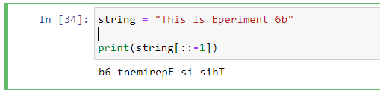

**Learning outcomes (What I have learnt):**

1. Learnt different operations performed on strings.

**Evaluation Grid (To be created as per the SOP and Assessment guidelines by the faculty):**

|  |  |  |  |
| --- | --- | --- | --- |
| **Sr. No.** | **Parameters** | **Maximum Marks** | **Marks Obtained** |
| **1.** | **Student Performance**  **(Conduct of experiment)**  **Objectives/Outcomes.** | 12 |  |
| **2.** | **Viva Voce** | 10 |  |
| **3.** | **Submission of Work Sheet**  **(Record)** | 8 |  |